BICoE Duplicate Scenarios — Problem Statement, Downstream and Pipeline Impact
Oct 8, 2026 · @Vino

1. Problem statement
The same MQS quote event is being stored more than once in BICoE through five different duplicate scenarios. Depending on the scenario, the duplicates reach Silver and Gold, are exposed through Pricing ART views, and cause the DVLA retention pipeline to fail.
Today's only duplicate control is the ingestion deduplication between landing and Bronze. It removes copies that are identical and arrive within a short streaming window. It does not recognise:
- copies that arrive on a later day
- copies whose attributes differ (quoteStep)
- copies loaded outside the normal stream (the header-fix backfill)
There is also no agreed business definition of "one quote event" that downstream layers could enforce.
There is a second, separate problem. The landing table (ehubstream) keeps every physical copy, even those removed before Bronze, and the DVLA retention pipeline reads and rewrites landing. As a result, every scenario can fail the DVLA retention pipeline, including those that never reach Bronze.
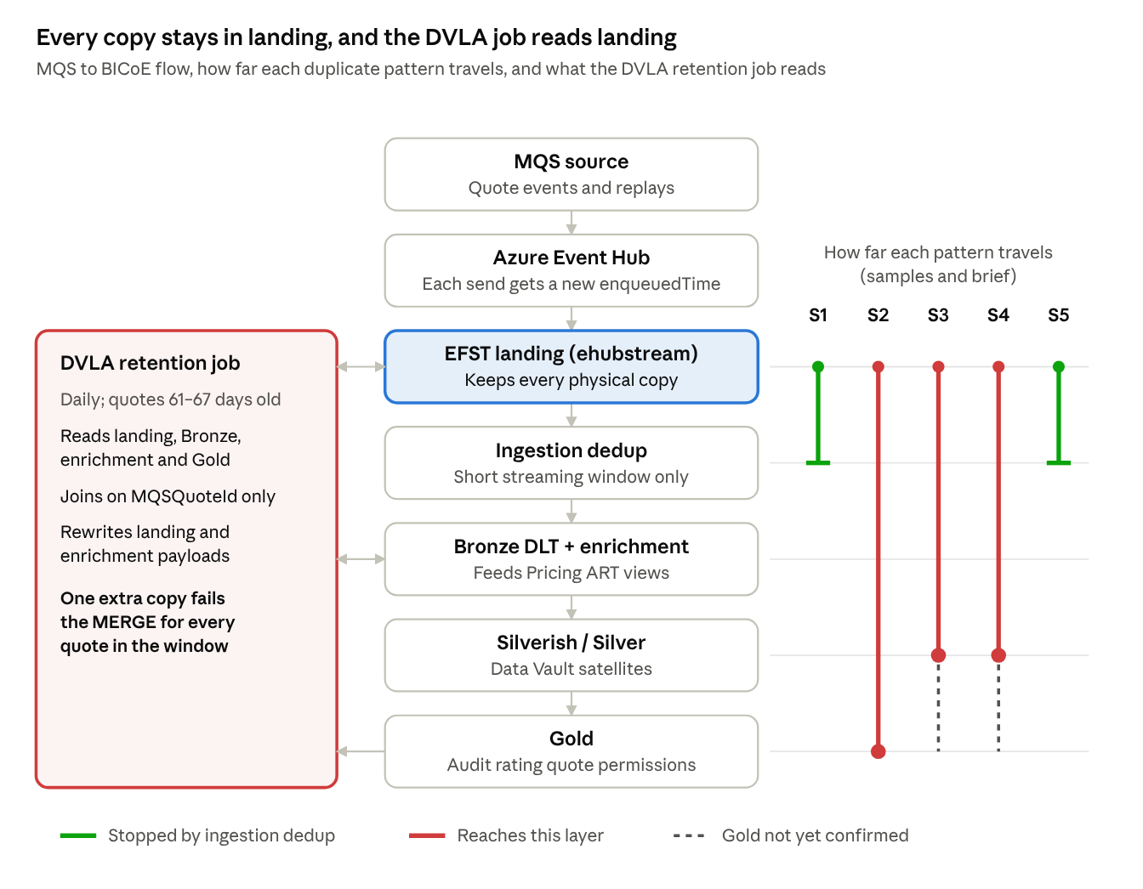
MQS → BICoE data flow · how far each scenario travels · what the DVLA retention job reads
Scope: MQS → Event Hub → EFST landing (ehubstream) → ingestion dedup → Bronze DLT + enrichment → Silverish / Silver → Gold, plus the consumers Pricing ART views, reconciliation and the DVLA retention pipeline.
Sources:
- the BICoE Duplicate Patterns — Leadership & Architecture Decision Brief
- production samples traced layer by layer for each scenario
- the DVLA retention notebook and its failure message

2. Impact summary
The DVLA retention pipeline is impacted by all five scenarios. Scenario 2 is the widest downstream exposure, because it reaches Gold.
Scenario | Nature | Bronze + enrichment | Silver | Gold | Pricing ART views | Reconciliation | DVLA retention pipeline | Severity
S1 Same-day replay | Ongoing | Clean | Clean | Clean | No impact | No impact | Fails (code analysis) | Medium
S2 Cross-day replay | Ongoing | Duplicated | Duplicated | Duplicated | Impacted | To confirm | Fails (code analysis) | High
S3 Different quoteStep | Ongoing (8–30 Sep 2026) | Variants | Variants | To confirm | Impacted | To confirm | Expected to fail | Medium–High
S4 Header-fix reload | One-off (historical) | Duplicated | Duplicated | To confirm | Potential | No impact (own dedup) | Fails (confirmed) | High
S5 Exact upstream replay | Ongoing | Clean (sample) | Clean (sample) | Clean (sample) | Potential | To confirm | Fails (confirmed) | High
"Confirmed" means observed in production per the brief. "Code analysis" means derived from the DVLA notebook code applied to the production samples (section 8).

3. Scenario 1 — Same-day replay duplicates
Problem statement. The same logical MQS message arrives several times on the same day, each copy with a slightly different Event Hub enqueue time (milliseconds or microseconds apart). Ingestion dedup removes the extra copies before Bronze, but every copy stays in landing.
How it happens. Upstream resends the message in a burst. All copies arrive inside the streaming dedup window, so only one passes to Bronze.
Evidence. Quote MQS-02b5206f… had ten mqs-quote-request copies landed on 26 Sep 2026 between 02:00:00.429 and 02:00:00.526, two of them with identical enqueuedTime. Bronze, enrichment, Silverish, Silver and Gold each hold one row. Bronze kept the 02:00:00.503 copy rather than the earliest one.
Downstream impact
Layer / consumer | Impact | Status
EFST landing (ehubstream) | 10 copies retained | Observed
Bronze DLT + enrichment | 1 row; the survivor is not the earliest copy | Observed
Silverish / Silver | 1 row | Observed
Gold | 1 row | Observed
Pricing ART views | None | Brief
Reconciliation | None | Brief
Pipeline failures
- DVLA retention, step 1 (MERGE into ehubstream) fails. The two landing copies with identical enqueuedTime each produce a source row matching the same target row, which raises DELTA_MULTIPLE_SOURCE_ROW_MATCHING_TARGET_ROW_IN_MERGE.
- DVLA retention, step 2 (MERGE into dlt_raw_enrichments) fails. All ten landing copies produce source rows for one MQSQuoteId, and step 2 matches on MQSQuoteId only. This assumes tmpDVLARemoved is the step 1 output.
- No failure in the Bronze, Silver or Gold loads.
Business impact. Reporting is unaffected, but DVLA data retention can fail for every quote in the job's window when an S1 quote is in it. The brief rated this scenario "contained"; that holds for Bronze to Gold only.

4. Scenario 2 — Cross-day replay duplicates
Problem statement. A message is processed on one day and the same logical message is replayed on a later day with a new Event Hub enqueuedTime. The replay falls outside the ingestion dedup window, so it is treated as a new event and flows through every layer to Gold.
How it happens. Upstream replays the message on a later day; in the sample, the replays arrive at about 02:00 UTC. Ingestion dedup only remembers records inside its short watermark window. The Silver satellite then inserts a new row for each arrival, because LOAD_DT and DWH_ANCHOR_DT differ even though the business key and EVENT_DTS are the same.
Evidence. Quote MQS-59908abc… had mqs-quote-request landed four times:
- 22 Sep 15:25:37.578 (original)
- 22 Sep 15:25:41.242 (same day; removed by dedup)
- 23 Sep 02:00:04.034 (replay)
- 25 Sep 02:00:13.607 (replay)
Three rows then appear in every layer through to Gold. They share QUOTE_MQS_QUOTE_LNK_KEY and RATING_QUOTE_KEY, and differ only in LOAD_DT, DWH_ANCHOR_DT and DWH_DATA_DTS.
Downstream impact
Layer / consumer | Impact | Status
EFST landing | 4 copies retained | Observed
Bronze dlt_quote_request | 3 rows | Observed
Enrichment dlt_raw_enrichments | 3 rows | Observed
Silverish / Silver satellites | 3 rows, one per arrival day (22, 23, 25 Sep) | Observed
Gold dim_audit_rating_quote_permissions | 3 rows with the same RATING_QUOTE_KEY | Observed
Pricing ART views | Both copies exposed, because the views read DLT | Expected (brief)
Reconciliation | Unknown | To confirm
Pipeline failures
- DVLA retention, step 1 fails. Each landing row joins to 3 enrichment × 3 Bronze × 3 Gold rows, giving 27 source rows per target row (108 in total), so the MERGE cannot run.
- DVLA retention, step 2 fails. There are multiple source rows per MQSQuoteId.
- The Silver and Gold loads do not fail; they silently insert duplicates.
Business impact.
- Gold reporting counts the quote three times, on three different dates, so any date-partitioned metric is inflated.
- Pricing ART users may see duplicate quotes.
- DVLA retention fails for every quote in the window.
- Clean-up does not prevent recurrence.

5. Scenario 3 — Same MQSQuoteId + messageType, different quoteStep
Problem statement. Several records arrive with the same MQSQuoteId and messageType but different quoteStep values. This is a source defect: MQS reported it fixed, but it recurred in production from about 8 to 30 September 2026. Because the records are not identical, no current control treats them as duplicates, and all variants flow downstream.
How it happens. MQS emits more than one version of the same quote message with different quoteStep values. Ingestion dedup compares whole records, so each variant passes as a distinct event.
Evidence. No production sample has been supplied yet; the impact below is from the brief and code analysis.
Downstream impact
Layer / consumer | Impact | Status
EFST landing | Multiple variants retained | Brief
Bronze DLT + enrichment | Multiple variants | Brief
Silverish / Silver | Multiple variants; unclear which reflects the true quote state | Brief
Gold | Unknown | To confirm
Pricing ART views | Multiple variants of one quote exposed | Expected (brief)
Reconciliation | Unknown | To confirm
Pipeline failures
- DVLA retention, steps 1 and 2 are expected to fail. More than one dlt_quote_request row per quote multiplies the step 1 source rows, and step 2 receives more than one row per MQSQuoteId.
- No failure in the Bronze, Silver or Gold loads.
Business impact.
- A correctness problem, not only a counting one: consumers may act on the wrong quote step.
- Fixing it by deleting "duplicates" on MQSQuoteId + messageType alone risks removing valid data until MQS defines which quoteStep is correct.

6. Scenario 4 — Historical header-fix / data-load duplicates
Problem statement. During the header-issue correction and backfill, the same historical data was loaded into the EFST landing flow more than once. This is a finite, one-off data-load error rather than ongoing replay behaviour, but the duplicates it created are still present in DLT, Silver and enrichment for the affected period.
How it happens. Each manual load was processed separately. The source/event time is the same across copies, but TimeEnqueued differs slightly. The loads bypassed the normal streaming path that ingestion dedup protects, so every copy flowed downstream.
Evidence (sample assumed to be S4; tab name not visible). Quote MQS-8f24e86a… on 6 Aug 2026 had two rating-request records, both with quoteStep GetQuote, landed 2.7 s apart (10:46:44.582 and 10:46:47.274). Their Event Hub offsets are out of order (20158653, then 20158046), which fits a separate re-load. Both rows reached dlt_rating_request_v2 and dlt_rating_request_dvla_removed_v2.
Downstream impact
Layer / consumer | Impact | Status
EFST landing | Duplicate copies for the backfill period | Brief + sample
Bronze DLT (dlt_rating_request_v2) | 2 rows per affected quote | Observed
Enrichment | Duplicate enrichment records | Brief
Silverish / Silver | Historical duplicates for the affected period | Brief
Gold | Unknown | To confirm
Pricing ART views | Historical exposure where affected DLT tables feed the views | Potential (brief)
Reconciliation | None; it applies its own dedup | Brief
Pipeline failures
- DVLA retention fails (confirmed). The retention merge finds multiple matching records for one quote and the pipeline fails. In the sample, the DVLA-facing table dlt_rating_request_dvla_removed_v2 holds two rows for the quote.
- The rating-request DVLA job code was not provided, so the exact failing step on this path is still to confirm.
Business impact.
- DVLA retention has been failing for the affected period.
- Historical reporting and enrichment for that period carry duplicates.
- Because it is finite, it is resolved by a one-off clean-up plus a successful retention rerun; it is not a model for the ongoing scenarios.

7. Scenario 5 — Exact upstream replay duplicates
Problem statement. For certain cases, the upstream system resends exactly the same message, identical in every field including TimeEnqueued. This is ongoing behaviour. EFST lets the identical copy land. In the sample, ingestion dedup removed it before Bronze, but both copies stay in landing, and that is enough to fail the DVLA retention pipeline.
How it happens. Upstream replays the message byte-for-byte. Landing accepts both physical records. Inside the dedup window the copy is removed; per the brief, exact replays are not prevented end to end, so a copy arriving outside the window would flow downstream as in S2.
Evidence. Quote MQS-a8acfa1c… on 7 Oct 2026 had two fully identical mqs-quote-request rows (enqueuedTime and TimeEnqueued 11:29:04.455, writeTimestamp 11:29:05.684). Bronze, enrichment, Silverish, Silver and Gold each hold one row, and the Pricing view was marked N/A.
Downstream impact
Layer / consumer | Impact | Status
EFST landing | 2 identical copies retained | Observed
Bronze DLT + enrichment | 1 row in sample; duplicates possible outside the dedup window | Observed / brief
Silverish / Silver | 1 row in sample | Observed
Gold | 1 row in sample | Observed
Pricing ART views | Potential, where affected DLT feeds the view | Brief
Reconciliation | Unknown | To confirm
Pipeline failures
- DVLA retention, step 1 fails (confirmed). The two identical landing rows produce two identical source rows that match the same target row.
- DVLA retention, step 2 fails. There are two source rows for one MQSQuoteId.
- This explains why the retention failure is confirmed even though Bronze to Gold is clean.
Business impact.
- DVLA retention fails repeatedly, because the behaviour is ongoing.
- One-off clean-up is not enough: every new replay re-creates the failure until upstream stops resending or the pipeline tolerates copies.

8. DVLA retention pipeline failure (all scenarios)
The DVLA retention pipeline fails with DELTA_MULTIPLE_SOURCE_ROW_MATCHING_TARGET_ROW_IN_MERGE whenever any duplicated quote is in its window. It builds its MERGE source from landing, which keeps every copy, and joins its inputs on MQSQuoteId alone.
Step | Target | Source | Match key
1 | mqs_athn_mtr.ehubstream (landing) | ehubstream (mqs-quote-request) joined to dlt_raw_enrichments, dlt_quote_request and dim_audit_rating_quote_permissions on MQSQuoteId; quotes 61–67 days old; excludes "Athena Motor Sale" | MQSQuoteId + messageType + enqueuedTime
2 | mqs_athn_mtr.dlt_raw_enrichments | tmpDVLARemoved | MQSQuoteId only
Why duplicates break it. Delta MERGE fails the whole statement when two source rows match the same target row. In step 1, each landing row produces (enrichment rows × Bronze quote-request rows × Gold rows) source rows for that quote. Identical landing rows also collide.
Scenario (sample) | Landing | Enrichment | Bronze | Gold | Step 1 source rows | Result
S1 | 10 (2 identical) | 1 | 1 | 1 | 10 | Fails
S2 | 4 | 3 | 3 | 3 | 108 | Fails
S3 | ≥ 1 | ≥ 1 | ≥ 2 | ≥ 1 | ≥ 2 per row | Expected to fail
S4 | Rating-request path (code not provided) |  |  |  |  | Fails (confirmed)
S5 | 2 identical | 1 | 1 | 1 | 2 identical | Fails (confirmed)
Impact of the failure.
- All-or-nothing. One duplicated quote stops DVLA data removal for every eligible quote in that day's window.
- Repeats for up to 7 days. The window rolls daily over 7 days (current_date − 67 to − 61), so the same duplicate fails consecutive runs.
- Permanent gaps. A quote whose seven eligible runs all fail never has its DVLA data removed, and no report flags it.
- Payload cross-wiring. Joining on MQSQuoteId alone pairs every landing copy with every enrichment and quote-request copy. Where copies differ (S3), one copy's payload can overwrite another's.
The S1, S2 and S3 failures are derived from the notebook code applied to the samples. They should be verified by running the step 1 source query for those quotes.

9. Open points to confirm
Open point | Scenarios | Owner
Production sample showing differing quoteStep (8–30 Sep) | S3 | BICoE Dev
Confirm that the 6 Aug rating-request sample is S4; provide the rating-request DVLA job code | S4 | BICoE Dev
tmpDVLARemoved definition (step 2 source) | All | BICoE Dev
Gold impact for S3 and S4 | S3, S4 | Glenn / Gold owner
Pricing ART view sources and any view-level filtering | S2–S5 | Pricing ART
Reconciliation behaviour | S2, S3, S5 | BICoE Dev
Root cause of replays, including what runs at about 02:00 UTC daily | S2, S5 | MQS

